# What is a breakpoint?

* Breakpoints are the viewport **WIDTH** where we want our design to change
* Breakpoints are the pixel values we want to put in our media queries

# Strategies for selecting breakpoints

* Based on screen width ranges
* We group in Phones, Tablets, Laptops
* And group together in a logical way

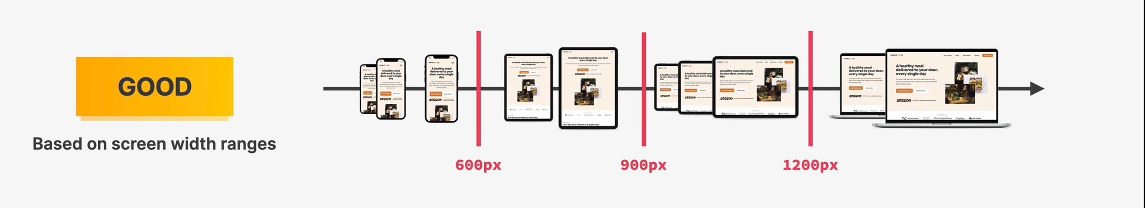

* Most phones are between 300 and 600 px
* Most tables are between 600 and 900 px
* Landscape tablets are between 900 and 1200px
* Laptops are over 1200px

# BEST STRATEGY

* Set breakpoints where **DESIGN BREAKS DOWN**

1. We begin at one screen size
2. We start increasing the width
3. As soon as the design breaks, we create a breakpoint